Web Services Testing using SOAP UI

* SOA and Web services

SOA i.e. service oriented architecture is distinct approach of separating concerns and building business solutions using loosely coupled, reusable components

* Building blocks of SOA
  + Web services
* individual units of business logic in SOA
* communicate with other systems and programs through messages

* Service container
* is the SOA middle ware container where the web service is hosted for

1. consuming applications to interact with it

* Allows developers to build, operate, deploy and manage web services
* Also represents a server side processor role in the web services framework

Service container contains the business logic and it interacts with the service consumer using the service interface

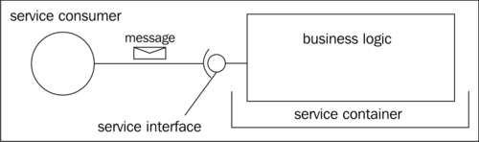

* Mediation

The transmission of messages in a between nodes in a service-oriented solution does not just occur over point to point channels.

The messages are passed through series of intermediaries and subjected to transformations and conversions

This process is mediation

Broker is the SOA middle ware component for mediation

Enterprise Service Bus ESB is the broker

* Composition

Usually webservices are pulled together dynamically at runtime based on the rules specified in business process definitions.

The management and coordination of these business processes are governed by process coordinator which is the SOA middleware component associated with the webservice solutions